OTD
OUTFIT OF THE DAY
Frontend Product Handoff — Balaji
What to build • What every interaction must do • What must connect later

OTD is a mobile-first AI personal fashion companion. The frontend is not just a collection of screens: it is the user journey that connects the wardrobe, personal style, destination, occasion, weather, mood and AI outfit recommendation.

1. The OTD product you are building
The core experience is: the user gives OTD their wardrobe and personal style, tells OTD where they are going and what the occasion/mood is, and OTD returns a personalized outfit using the user's available clothes.
- Smart Item Upload → AI recognizes clothing and stores item attributes.
- Digital Closet → user's real wardrobe, organized and searchable.
- Personal Style Profile → body/fit information, preferences, colors, style identity and goals.
- Destination Intelligence → destination/venue/context can influence the recommendation.
- Occasion + Time + Weather + Mood/Vibe → context for the look.
- AI Outfit Engine → creates a complete look from available wardrobe items.
- AI explanation → tells the user why the outfit fits the context.
- AI Stylist chat → user can ask for changes such as different shoes, more casual, more attractive, etc.
- Save / History → user can save looks and revisit previous recommendations.
- Virtual Try-On / Avatar → planned capability; frontend should be structured so it can plug in later.
Important: do not hard-code AI results or make the UI depend on fake permanent content. Use mock data only while the APIs are being connected.

2. Design language — must stay consistent
- Primary visual direction: premium, clean, timeless and gender-neutral.
- Base palette: warm beige/cream + black/charcoal, with restrained accent use.
- OTD logo and the 'Your style. Every place.' brand language should remain consistent.
- Typography: elegant serif for major fashion/editorial headings; clean sans-serif for UI/body text.
- Avoid overly feminine styling, excessive gradients, neon/glowing AI effects or clutter.
- Cards, buttons, chips and navigation should use one consistent design system.
- Mobile-first: design for a phone screen first; responsive behavior comes after the mobile structure is correct.
- Use real clothing imagery where appropriate, but keep image ratios/cropping consistent across the product.
- All buttons need clear pressed/disabled/loading states.

3. App navigation — the persistent structure
Area | Purpose | Primary actions | Notes
OTD / Home | Generate today's look | Create My Look, edit context, view recommendation | Main entry point
Closet | Manage wardrobe | Add Piece, search, filter, edit item | Must support empty/loading/error
Try-On | Visualize a selected look | Select pieces, Try On | Can initially be a structured placeholder
Feed / Explore | Style inspiration | Open post, save, share | Can be phased if needed
Profile / More | Personalization + account | Edit profile, style, settings | Profile is important to AI inputs

4. Screen-by-screen frontend requirements

A. Welcome / Splash
- OTD logo
- Outfit of the Day / brand line
- Subtle loading transition
- Do not make the splash unnecessarily long
States / behavior: App launch → onboarding/login • Returning user → session check → home

B. Login / Sign Up
- Email/phone field
- Password field
- Show/hide password
- Continue / Sign In
- Create account
- Forgot password
- Optional social sign-in slot if backend supports it
States / behavior: Validation • Loading state • Wrong credentials state • Network error state • Success → onboarding or home

C. Personal Details Onboarding
- Name
- Age/date-of-birth if product requires it
- Gender/identity option only if needed for personalization
- Height
- Body/fit information
- Skin tone / appearance inputs where appropriate
- Continue
- Back
- Skip where product allows
States / behavior: Progress indicator • Inline validation • Persist draft so user does not lose progress

D. Style Preferences
- Style categories
- Preferred colors
- Avoided colors
- Fit preference
- Formal/casual range
- Style tags
- Continue / Back
States / behavior: Multi-select chips • Selected/unselected states • Search if option list becomes large

E. Goals / OTD Personalization
- What user wants OTD to help with
- Daily outfits
- Occasions
- Using existing wardrobe
- Trying new combinations
- Style confidence
- Save / Continue
States / behavior: Selections become profile data for future AI requests

F. Home / Dashboard
- Greeting
- Today's weather/context summary
- Create My Look CTA
- Recent/saved look
- Closet summary
- Quick actions
- Bottom navigation
States / behavior: Empty closet state • First-time user guidance • Returning-user personalized state

G. Destination + Occasion
- Where are you going?
- Destination search/input
- Venue/place selection when applicable
- Occasion
- Date/time
- Continue
States / behavior: Location permission if needed • Search/loading/error • Recent destinations • Do not assume every destination is a physical venue

H. Mood + Weather / Context
- Mood/Vibe selection
- Elegant, attractive, casual, effortless, romantic, bold, etc.
- Weather auto-fetch when available
- Manual weather/context fallback
- Time of day
- Continue / Generate
States / behavior: Selected chips • Weather loading • Permission denied fallback

I. AI Generation / Thinking State
- OTD branding
- Progressive status messages
- Wardrobe scan state
- Context analysis state
- Look generation state
- Cancel/back if safe
States / behavior: Never pretend a result exists before the API returns it • Handle timeout/retry

J. AI Outfit Recommendation
- Outfit title
- AI match/relevance indicator
- Complete outfit
- Item cards
- Wear This Look / Use This Look
- Why This Look?
- Modify Look
- Save
- Share
- Regenerate
States / behavior: Items must map to real closet IDs • Unavailable item must be handled • Scrollable details

K. Why This Look?
- Context match
- Weather reasoning
- Occasion reasoning
- Color/style reasoning
- Wardrobe utilization reasoning
- AI explanation
States / behavior: Close/back • No unsupported claims

L. AI Stylist / Modify
- Chat input
- Suggested prompts
- Send
- Current look context
- Updated recommendation
States / behavior: Examples: 'Make it more casual', 'Change the shoes', 'No jeans', 'Make it more attractive' • Loading and retry

M. Digital Closet
- All items
- Categories
- Search
- Filter/sort
- Add Piece
- Item card
- Item detail
- Edit
- Delete/archive
States / behavior: Empty closet • Upload progress • Recognition pending • Recognition failed

N. Smart Item Upload
- Camera
- Gallery
- Multiple upload if supported
- Crop/retake
- Upload progress
- AI recognition
- Confirm attributes
States / behavior: Category • Color • Pattern • Material/fabric if available • Brand/optional • Season • Formality/style tags • User correction

O. Saved Looks / History
- Saved looks
- Previous recommendations
- Date/context
- Open
- Reuse
- Delete
- Save again
States / behavior: Empty state • Pagination/lazy loading

P. Profile / Style DNA
- Profile photo
- Personal details
- Style preferences
- Body/fit profile
- Color preferences
- Goals
- Edit
States / behavior: Changes must be saved and reflected in future requests

Q. Try-On / Fitting Room
- Select outfit pieces
- Avatar/user image area
- Try On
- Generation status
- Result
- Retry
- Save
States / behavior: Build frontend so generation provider can be swapped later

R. Explore / Feed
- Style posts
- Categories/tags
- Open post
- Like/save/share
- User/profile card
States / behavior: This is secondary to the core styling loop; do not let it delay the core MVP

S. Notifications
- AI result ready
- Upload processing complete
- Important account/system messages
- Mark read
- Open related screen
States / behavior: Permission handling and empty state

T. Settings
- Account
- Privacy
- Permissions
- Notifications
- Data controls
- Help
- Logout
- Delete account
States / behavior: Sensitive actions need confirmation

5. The most important frontend interaction: Create My Look
- User opens OTD / Home.
- User selects or enters destination.
- User selects occasion and time.
- OTD obtains weather/context when permitted.
- User selects mood/vibe.
- Frontend sends the complete context plus the user's relevant wardrobe/profile IDs to the backend.
- Show a real loading/progress state while the AI pipeline works.
- Receive recommendation.
- Render outfit pieces from actual closet items.
- Allow Why This Look?, Save, Share, Regenerate and Modify.
- If user modifies the outfit, send the modification plus the current look context back through the API.
This flow is the heart of OTD. Every screen should ultimately support making this loop fast, understandable and enjoyable.

6. Buttons and interaction rules
Component | Required behavior | States
Primary CTA | Triggers the main action and prevents accidental duplicate submission. | Default / pressed / disabled / loading / success / error
Secondary button | Alternative action without competing with the primary CTA. | Default / pressed / disabled
Chip / filter | Select/deselect a style, category, mood, etc. | Unselected / selected / disabled
Icon button | Small contextual action; must have accessible label. | Default / pressed / disabled
Save | Persist current look/item to user's saved collection. | Unsaved / saved / loading / error
Add Piece | Opens upload flow. | Default / pressed
Generate | Starts outfit generation only when minimum context is valid. | Disabled until valid / loading / result
Modify | Opens AI Stylist with current look attached. | Default / loading
Regenerate | Requests another valid look using current context. | Loading / result / error
Delete | Deletes/archive only after confirmation when destructive. | Confirm / deleting / success / error
Back | Returns without losing valid draft state. | Default

7. Data the frontend must be ready to consume
- User profile: user ID, height/body/fit information, style preferences, colors, goals.
- Closet item: item ID, image URL, category, subcategory, color, pattern, material when available, style/formality tags, season, status.
- Context: destination, venue information when available, occasion, date/time, weather, mood/vibe.
- Recommendation: recommendation ID, selected item IDs, title, explanation, match/relevance information if returned, context snapshot.
- Saved look: look ID, recommendation ID, selected item IDs, created date, user notes if supported.
- Try-on request/result: request ID, selected item IDs, avatar/image reference, processing state, result URL.
- AI chat: conversation ID, current look/recommendation ID, user message, assistant response, updated item selection if returned.

8. Frontend ↔ Backend ↔ AI/ML boundaries
Frontend owns | Backend owns | AI/ML owns
Screens, navigation, components, interactions | Auth, users, persistence, APIs | Recognition/classification
Form validation + UI state | Closet data + item records | Clothing attributes
Rendering recommendation | Recommendation request/response orchestration | Recommendation/ranking logic
Upload UI + progress | File handling/storage integration | Image understanding
Chat UI | Conversation/session persistence | Styling/LLM response logic
Try-on UI + generation status | Generation job/API handling | Try-on/image generation
Error/loading/empty states | Reliable error contracts | Model/API failures and confidence handling

9. What you should NOT hard-code
- AI outfit names, explanations or match percentages.
- Weather values.
- User closet contents.
- User profile values.
- Venue intelligence.
- AI recognition results.
- Recommendation item IDs.
- Try-on results.
- Authentication state.
Use clearly labelled mock data during UI development, but keep the data structures close to the eventual API response.

10. Required reusable frontend architecture
- Reusable Button, IconButton, Chip, Card, Modal/Sheet, Input, Select, Image, Loading, Error, EmptyState and Toast components.
- Reusable ItemCard for closet pieces and outfit pieces.
- Reusable ContextChip for occasion, mood, weather and style.
- Central navigation/state approach so user context is not duplicated across screens.
- API/service layer separated from UI components.
- Environment variables for API URLs and service keys; never expose private secrets in the client.
- Image upload component with progress and failure handling.
- Consistent skeleton loaders for lists/cards.
- Accessible touch targets, readable text and clear contrast.
- Clean Git commits and branch discipline; do not mix unrelated changes in one commit.

11. MVP priority — build in this order
P0 — Must work: Login/auth, onboarding/profile, Home, Digital Closet, Smart Item Upload, context input, AI recommendation result, save look, AI modification/chat UI.
P1 — Next: History, stronger profile/style editing, richer destination intelligence UI, notifications, improved recommendation details.
P2 — Later: Virtual Try-On, Avatar, Explore/social feed, advanced analytics, shopping/affiliate and other expansion features.

12. Definition of Done for every screen
- Looks correct on the target mobile viewport.
- Navigation to and from the screen works.
- Every visible button has a defined action.
- Every form has validation.
- Loading, empty, error and success states are handled where applicable.
- Back behavior is defined.
- Data is not lost accidentally.
- API dependency is clearly identified.
- Mock data can be replaced without rewriting the UI.
- No private API keys/secrets are stored in frontend code.
- Components are reusable rather than duplicated.
- Screen has been tested on at least one iOS and one Android device/emulator if available.
- Console/runtime errors are resolved before marking complete.

13. Reference direction
Use the provided OTD reference visuals for the overall premium fashion direction, spacing, card treatment, imagery and product feel. They are references, not a reason to copy another product screen-for-screen. The final mobile UI should remain recognizably OTD.
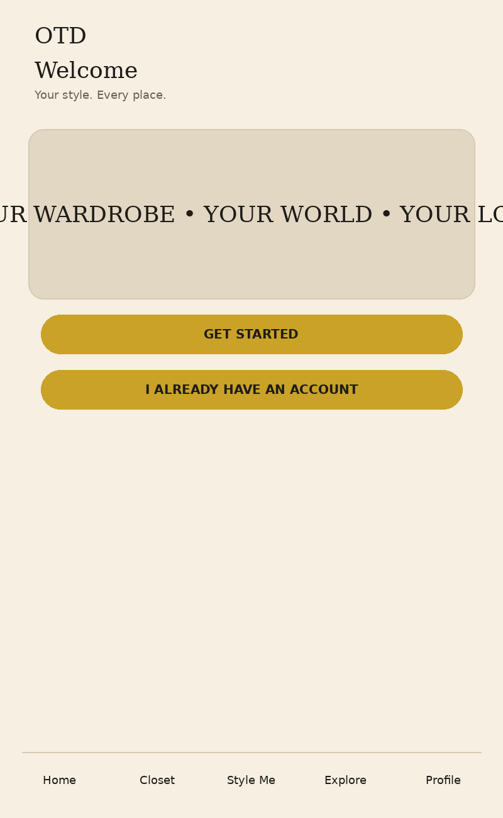
Reference 01 — OTD visual/product direction
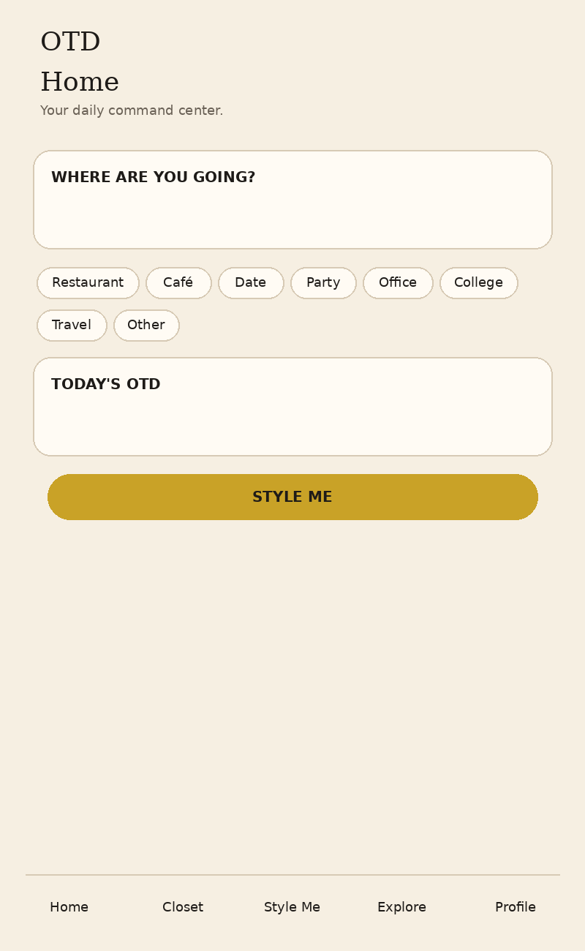
Reference 06 — wardrobe/closet direction
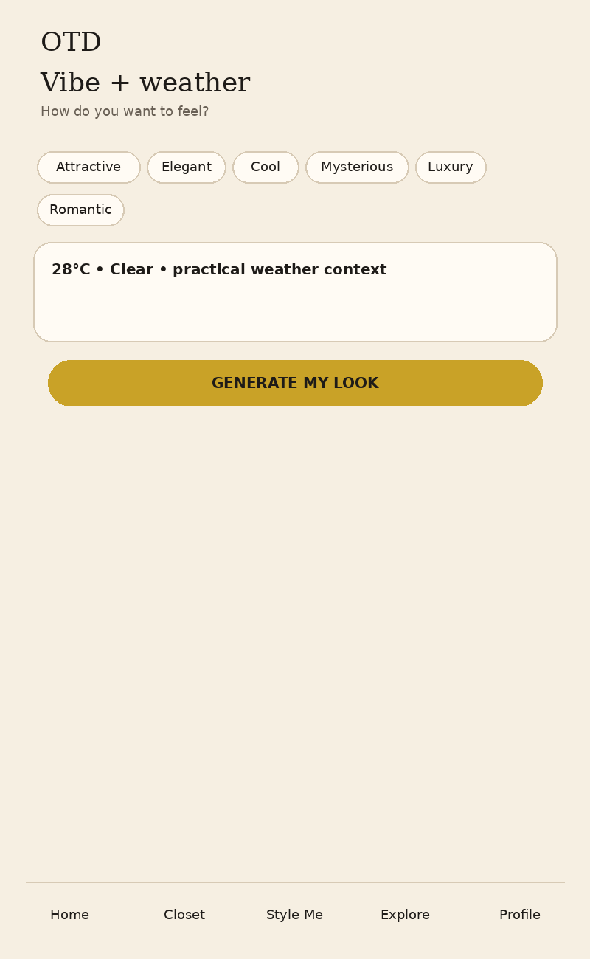
Reference 09 — recommendation direction

14. Immediate frontend deliverables
- Create the reusable OTD design system/components first.
- Create the complete mobile navigation and screen skeleton.
- Complete P0 screens in the order defined above.
- Use mock JSON/data objects that mirror the future API structures.
- Connect screens through the real user journey rather than presenting isolated designs.
- Coordinate with Vasant before deciding API field names or changing backend contracts.
- Coordinate with the AI/ML team before assuming what recognition/recommendation data will be returned.
- Keep a short frontend status: Done / In progress / Blocked / Next.

15. One rule for the OTD frontend
Build the interface around the OTD experience — not around individual screens.
The goal is not to make a beautiful prototype. The goal is to make every part of OTD ready to become a working product.

